

INSTITUTE OF COMPUTER SCIENCE AND DIGITAL INNOVATION
ACADEMIC SESSION: SEPT - DEC 2024
BIC1114/BBA1134: INTRODUCTION TO PROGRAMMING/PROGRAMMING FOR FINTECH

ASSIGNMENT DEADLINE: 1ST DECEMBER 2024

INSTRUCTIONS TO CANDIDATES

- This assignment will contribute 30% to your final grade.

- This coursework is a group assignment. You may have 3 members in one group.

- You are required to submit the codes and screenshot of all the possible the results.

IMPORTANT





Plagiarism is not allowed, and any student found to commit such an act, 0 mark will be awarded.
Coursework must be submitted on their due dates. If a coursework is submitted after its due date, the following penalty will be imposed:
- ONE day late : 3 marks deducted from the total marks awarded. ● TWO days late : 5 marks deducted from the total marks awarded.
- THREE or more days late: Assignment will not be marked and 0% will be awarded.

For example: A student scores 10 marks for an assignment that has a total mark of 10 If the assignment is submitted one day late, the marks awarded will be 7 marks.

You are also required to attach the screenshot of the results from the command prompt console.

Group 9:  Student Name: …Kong Kar Shin…….………….….  Student Name: …Lan Xin Yan…….……………......  Student Name: …Siow Qi Feng …….…………….... | Student ID: 1002371735  Student ID: 1002475404  Student ID: 1002371213
Subject Name: INTRODUCTION TO PROGRAMMING
Subject Code: BIC1114
Lecturer/Tutor: ASST. PROF. DR. SAMAR GHAZAL

Assignment Number/Title: Student Management System
Due Date: 1st DECEMBER 2024
Assignment Weightage: 30%

All work must be submitted by the due date.

Student’s Statement:
I hereby declare that the work submitted is my own. I confirm that I have read and understood the University regulations with regard to plagiarism, and that Plagiarism, Collusion and Cheating in this work will be penalized.

Note:
- You are expected to retain copies of your assignment report.

- If you require an acknowledgment receipt of this assignment, please prepare a duplicate copy of this form.
Student Signature: ….…………………
Date: …….1 DECEMBER 2024…….

Project Title: Student Management System
- Project Overview
This project involves building a command-line application to manage student information, allowing users to add, update, delete, and view student records. This system will help students practice core Python programming skills, including data structures, control flow, functions, and error handling.
CODING:
import json
import os
# Variables to store student records
students = {}
student_list = {}
DATA_FILE = "student_records.json"
# Main menu function
def main():
while True: # Infinite Loop until the user exits
print("Choose your option:")
print("1.Add Students")
print("2.Update Student")
print("3.Delete Student")
print("4.View All Student")
print("5.Save Records")
print("6.Load Records")
print("7.Search Records")
print("8.Exit")
choice = input("Enter Your Choice: ") # Input main menu choice
# Call respective functions based on user choice
if choice == "1":
add_student()
elif choice == "2":
update_student()
elif choice == "3":
delete_student()
elif choice == "4":
view_student()
elif choice == "5":
save_record()
elif choice == "6":
load_record()
elif choice == "7":
search_student()
elif choice == "8":
print("Exit")
exit() # Exit program
else:
print("Invalid Choice.")

OUTPUT:
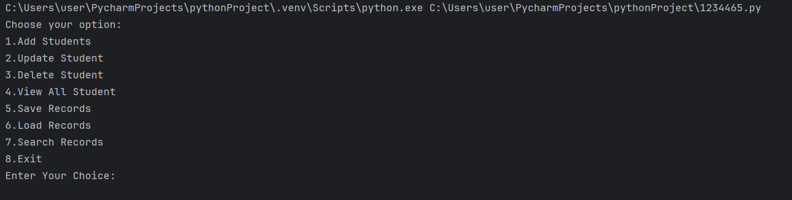

- Project Requirements and Learning Objectives
  - Adding Student Records
Function: Create a function, add_student(), where users can input details such as ID, name, age, course, and GPA.
Enhancements:
    - Implement data validation to ensure fields like GPA and age are within reasonable ranges.
    - Use error handling to prevent incorrect inputs (e.g., non-numeric values for age and GPA).

CODING:
# Function to add student records
def add_student():
try:
student_name = input("Enter Student Name: ") # Input student name
student_id = int(input("Enter Student ID: ")) # Input student ID
if student_id in student_list: # Check if the student ID already exists
print("This student ID already exists.")
return
# Input student age
student_age = int(input("Enter Student Age (10-100): "))
# Validate student age in between 10 and 100
while not (10 <= student_age <= 100):
print("Error. Student Age must be between 10 - 100.")
return
course = input("Enter The Course: ").upper() # Input course
GPA = float(input("Enter Student GPA (0.0 - 4.0): ")) # Input GPA
while not (0.0 <= GPA <= 4.0): # Validate GPA in between 0.0 and 4.0
print("Error. Student GPA must be between 0.0 - 4.0.")
return
# Add student record to the dictionary
student_list[student_id] = {
"student_name": student_name,
"student_age": student_age,
"course": course,
"GPA": GPA
}
print("Student added successfully.")
save_record() # Save records to the file
except ValueError: # Handle errors during loading
print("Invalid input. Please try again.")
save_record()
return

OUTPUT:
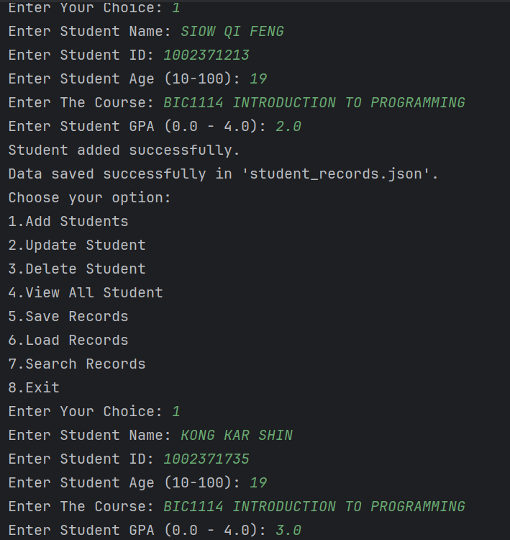
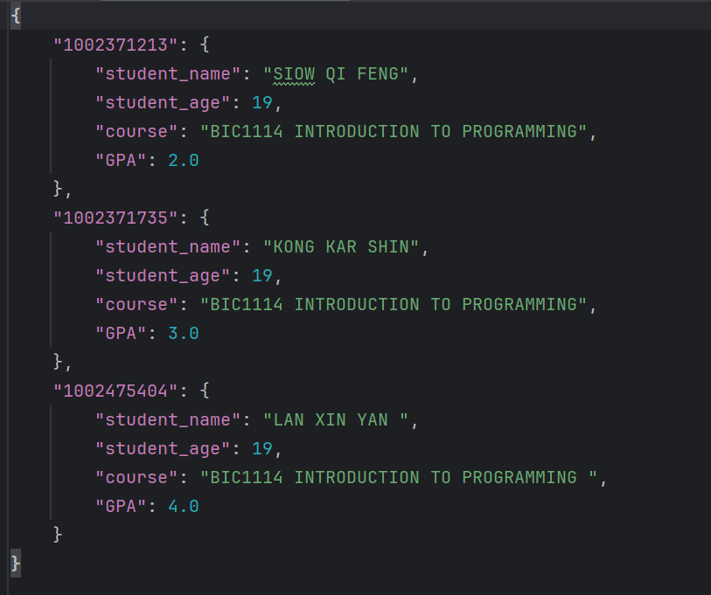

  - Updating Student Records
Function: Develop an update_student() function to modify a student's details based on their ID.
Enhancements:
    - Use control flow to check if a student ID exists before updating.
    - Provide options to update specific fields (e.g., only GPA or course) instead of all details at once.

CODING:
# Function to update current student record
def update_student():
# Input student ID
student_id = int(input("Enter Your Current Student ID: "))
if student_id not in student_list: # Check if the student ID exists
print("Error. Student ID not found.")
return
# Display options for update
print("Choose the option below to update.")
print("1. Student Name")
print("2. Student Age")
print("3. Course")
print("4. GPA")
choice = input("Enter Your Choice: ") # Input choice to update
if choice == "1": # Update name
new_name = input("Update Your Name: ")
student_list[student_id]["student_name"] = new_name
print("Student name updated successfully.")
save_record() # Save new records to the file
return
elif choice == "2": # Update age
try:
new_age = int(input("Update Your Age (10-100): "))
# Validate age in between 10 and 100
while new_age < 10 or new_age > 100:
print("Error. Age must be between 10 and 100.")
new_age = int(input("Enter Your Age (10-100): "))
student_list[student_id]["student_age"] = new_age
print("Student age updated successfully.")
save_record() # Save new records to the file
except ValueError: # Handle errors during loading
print("Invalid input. Age must be a number.")
return
elif choice == "3": # Update course
new_course = input("Update Your Course: ").upper()
student_list[student_id]["course"] = new_course
print("Course updated successfully.")
save_record() # Save new records to the file
return
elif choice == "4": # Update GPA
try:
new_GPA = float(input("Update Your New GPA (0.0 - 4.0): "))
# Validate GPA in between 0.0 and 4.0
while new_GPA < 0.0 or new_GPA > 4.0:
print("Error. GPA must be between 0.0 and 4.0.")
new_GPA = float(input("Enter GPA (0.0 - 4.0): "))
student_list[student_id]["GPA"] = new_GPA
print("GPA updated successfully.")
save_record() # Save new records to the file
except ValueError: # Handle errors during loading
print("Invalid input. GPA must be a number.")
return
else:
print("Invalid choice. No updates were made.")
return

OUTPUT:
IF UPDATE STUDENT NAME:
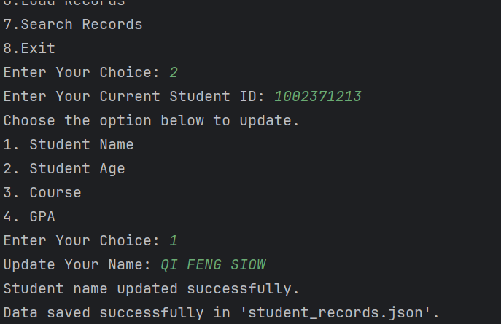

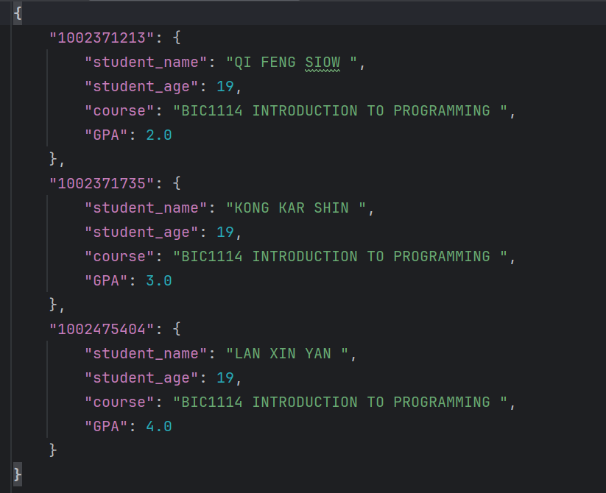

IF UPDATE STUDENT AGE:
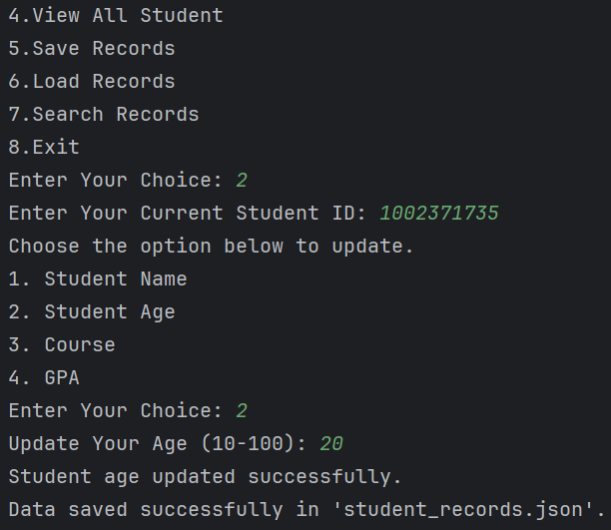

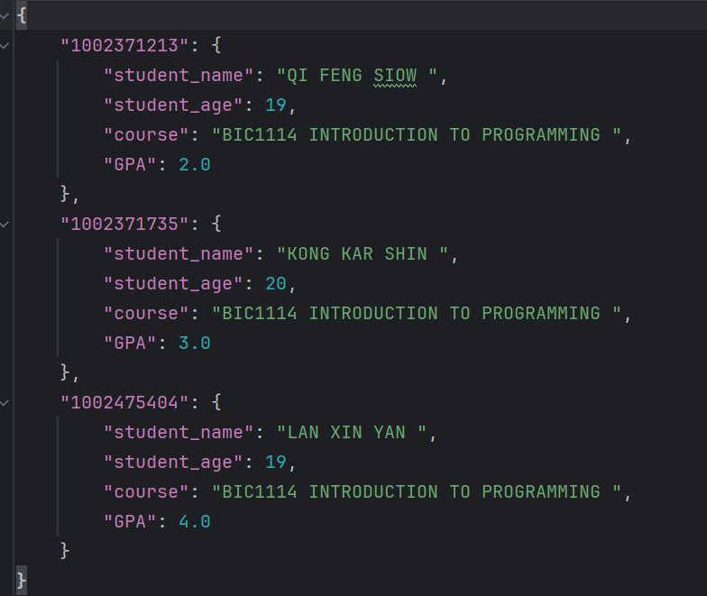

IF UPDATE COURSE:
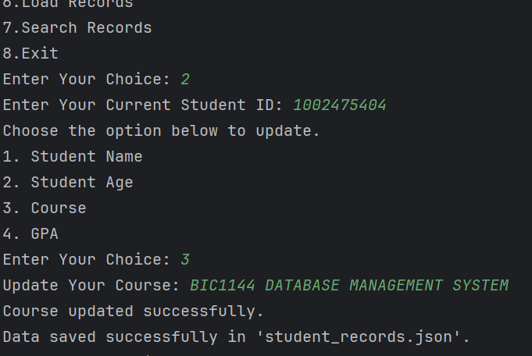

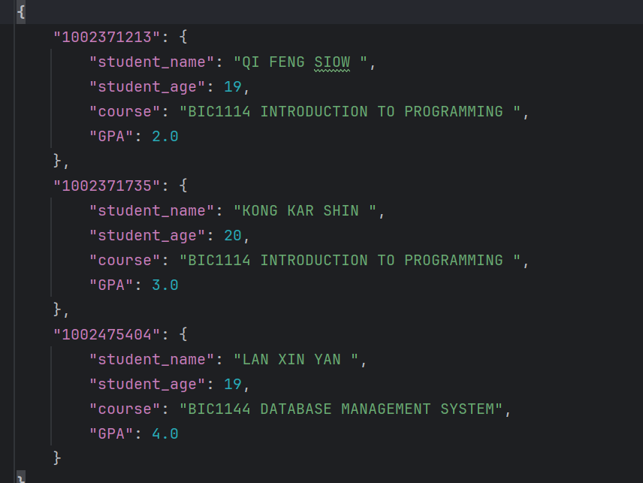

IF UPDATE GPA:
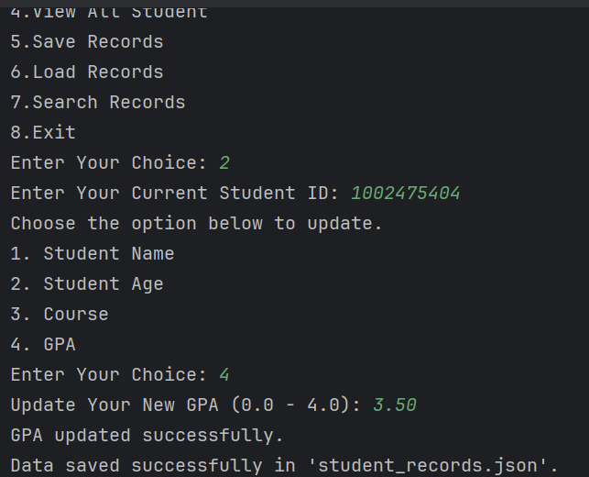

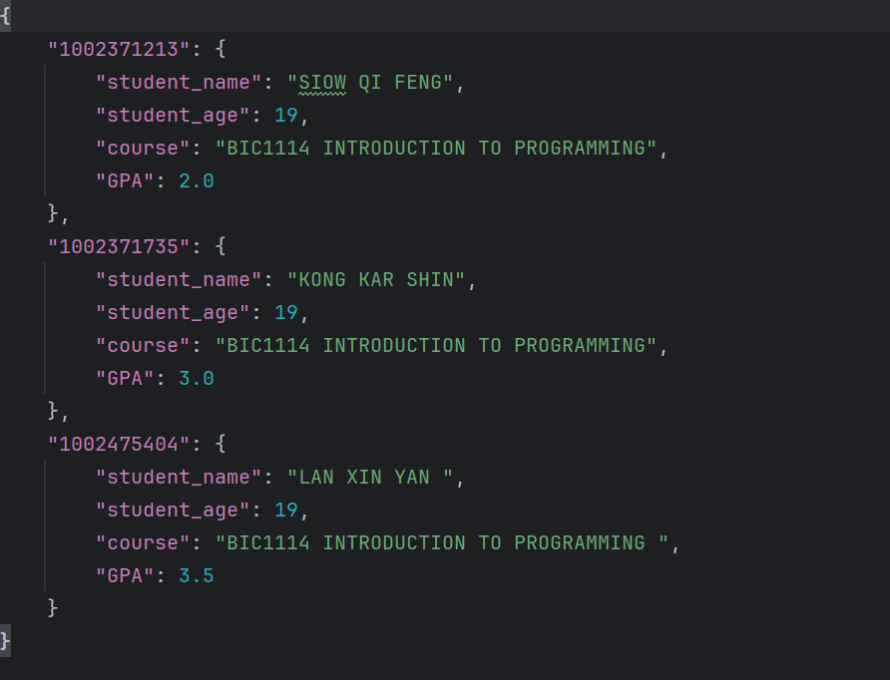

  - Deleting Student Records
Function: Implement a delete_student() function that allows users to remove a record by entering the student ID.
Enhancements:
    - Add a confirmation step before deleting a record to prevent accidental deletions.
    - Handle cases where the student ID does not exist in the system.

CODING:
# Function to delete student record
def delete_student():
try:
# Input student ID
student_id = int(input("Enter Your Current Student ID: "))
if student_id not in student_list: # Check if the student ID exists
print("Error. Student ID not found.")
save_record()
return
else:
print("Are you sure you want to delete it? (YES/NO)")
delete = input("Enter (YES/NO): ") # Confirm deletion
delete = delete.upper()
if delete == "YES":
# Delete student record in the file
del student_list[student_id]
print("Student deleted successfully.")
save_record() # Save new records to the file
return
else:
print("Delete unsuccessful.")
save_record()
return
except ValueError: # Handle errors during loading
print("Invalid input. Please try again.")

OUTPUT:
IF YES:
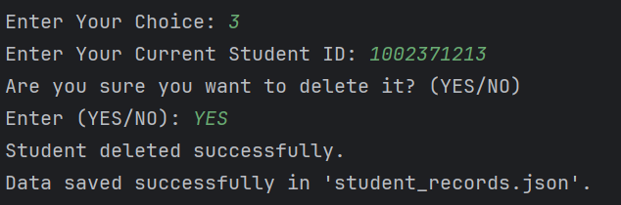
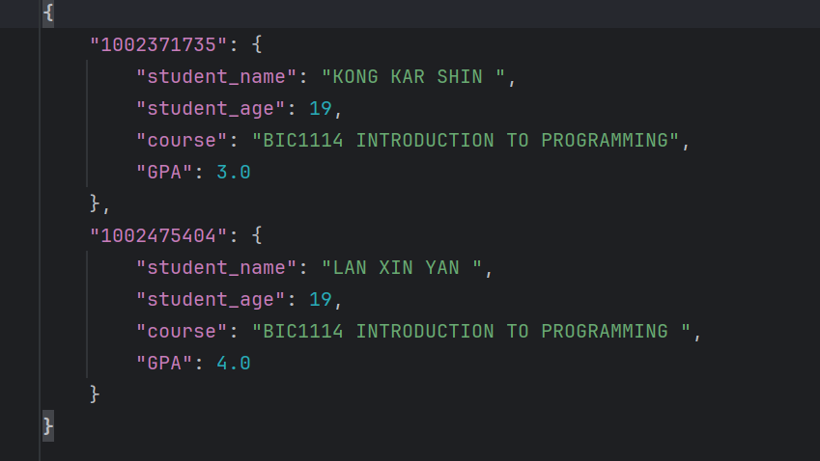
IF NO:
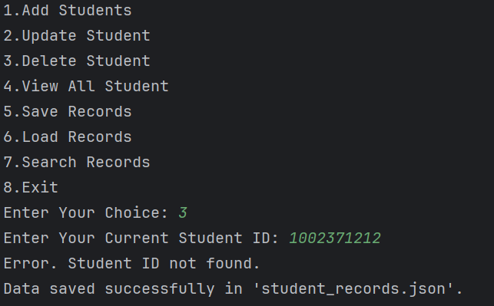
  - Viewing All Student Records
Function: Create a view_students() function to display all student records in a formatted table.
Enhancements:
    - Allow filtering by course or sorting by GPA to make the display more user-friendly.
    - Format the display for easy readability (e.g., aligning columns or truncating long names).

CODING:
# Function to view all student records
def view_student():
try:
if not student_list: # Check if the list is empty
print("No student records available.")
return
# Print records in formatted table
print(f"{'Student ID':<12} {'Name':<20} {'Age':<5} {'Course':<50} {'GPA':<5}")
print("-" * 100)
for student_id, details in student_list.items():
print(
f"{student_id:<12} "
f"{details['student_name']:<20} "
f"{details['student_age']:<5} "
f"{details['course']:<50} "
f"{details['GPA']:<5.2f}"
)
# Handle errors during loading
except ValueError:(
print("Invalid input. Please try again."))
return

OUTPUT:
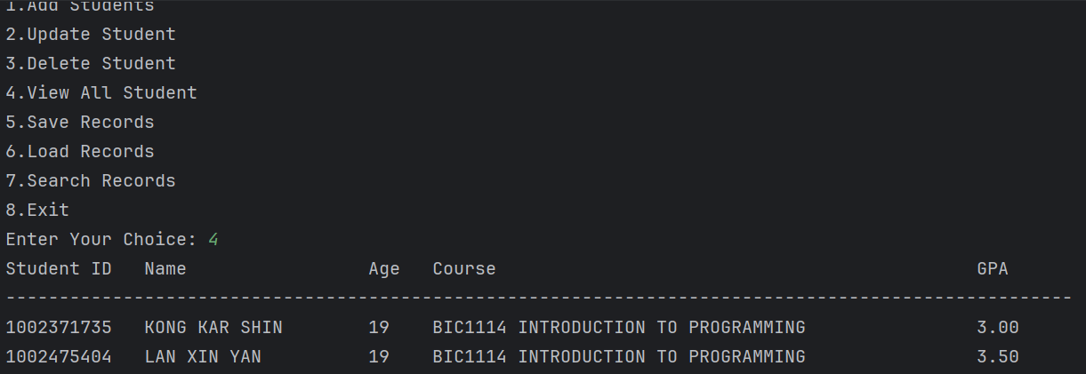
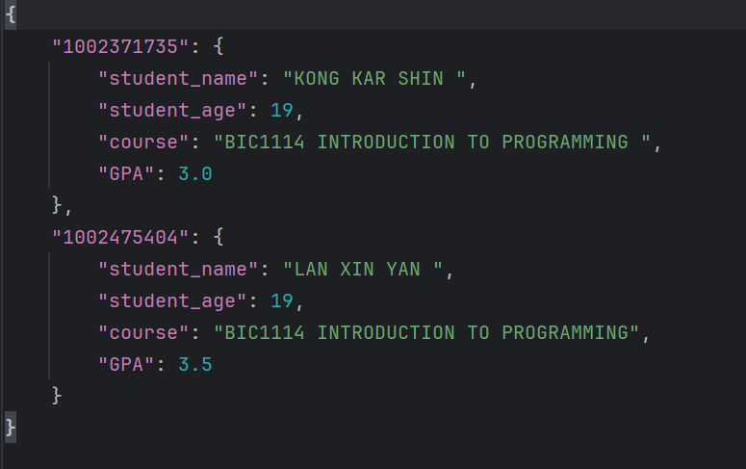

  - Saving and Loading Data
Functions: Implement save_records() and load_records() to save data to a file (e.g., CSV or JSON) and load it upon program start.
Enhancements:
    - Ensure that data is saved automatically upon adding, updating, or deleting records.
    - Add a "backup" feature that creates a separate backup file in case of accidental data loss.

CODING:
# Function to save records to JSON file
def save_record():
try:
with open(DATA_FILE, "w") as file: # Open the file in write mode
json.dump(student_list, file, indent=4) # Write data to the file
print(f"Data saved successfully in '{DATA_FILE}'.")
if not student_list: # Check if the list is empty
file.write("{}")
print("No student data to save.")
return
# Handle errors during loading
except ValueError:
print("Invalid input. Please try again.")
# Function to load student records
def load_record():
global student_list
try:
if not os.path.exists(DATA_FILE): # Check if the file exists
print(f"No data file found.")
student_list = {} # Initialise an empty list if no file exists
return
with open(DATA_FILE, "r") as file: # Open file in read mode
content = file.read()
if not content:
print(f"The file '{DATA_FILE}' is empty. Starting with an empty dataset.")
student_list = {}
else:
student_list = json.loads(content)
print(f"Data loaded successfully from '{DATA_FILE}'.")
except ValueError: # Handle errors during loading
print("Invalid input. Please try again.")
return

OUTPUT:
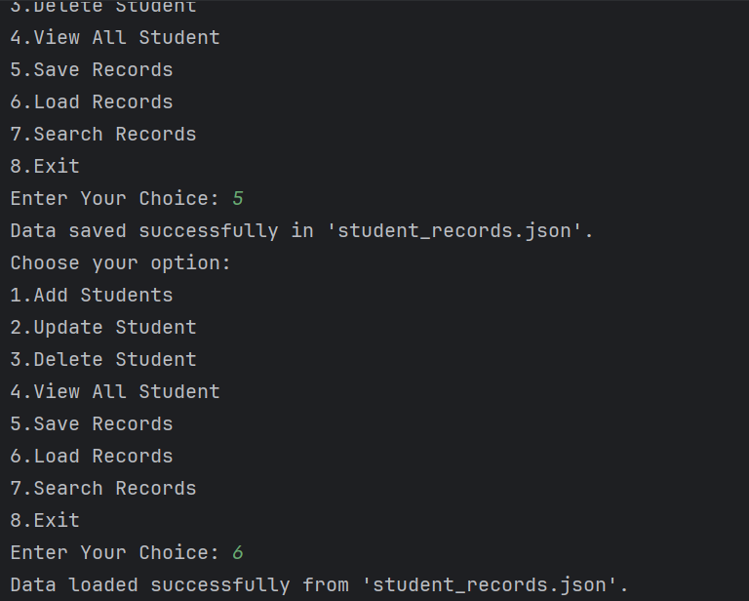

  - Search Functionality (Optional for Extra Practice)
Function: Create a search_student() function that lets users search for students by name, ID, or course.

CODING:
# Function to search student record
def search_student():
try:
if not student_list: # Check if the list is empty
print("No student records available.")
return
# Display search options
print("\nSearch the options:")
print("1. Search by Student Name")
print("2. Search by Student ID")
print("3. Search by Course")
# Input search option
choice = input("Choose an option (1/2/3): ")
results = [] # To store search results
# Search based on selected options
if choice == "1": # Search by name
name_query = input("Enter name to search: ")
results = [
(ID, info) for ID, info in student_list.items()
if name_query in info['student_name']
]
elif choice == "2": # Search by student ID
try:
id_query = int(input("Enter ID to search: "))
if id_query in student_list:
results = [(id_query, student_list[id_query])]
else:
print("No student found with that ID.")
except ValueError: # Handle errors during loading
print("Invalid ID. Please try again.")
elif choice == "3": # Search by course
course_query = input("Enter course to search: ")
results = [
(ID, info) for ID, info in student_list.items()
if course_query == info['course']
]
else:
print("Invalid choice. Please try again.")
return
# Display search results
if results:
print("\nSearch Results:")
print(f"{'ID':<12} "
f"{'Name':<20} "
f"{'Age':<5} "
f"{'Course':<50} "
f"{'GPA':<5}")
print("-" * 100)
for ID, info in results:
print(
f"{ID:<12} "
f"{info['student_name']:<20} "
f"{info['student_age']:<5} "
f"{info['course']:<50} "
f"{info['GPA']:<5.2f}"
)
else:
print("No matching records found.")
save_record()
# Handle errors during loading
except ValueError:(
print("Invalid input. Please try again."))
return
# Start the program by calling the main function
main()

OUTPUT:
